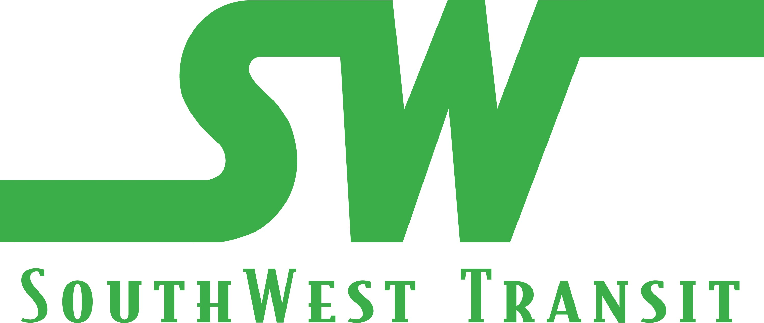 SOUTHWEST TRANSIT
______________________________________________________________________________

To: SouthWest Transit Commission

From: Len Simich, CEO

Date: February 24, 2020

Subject: Amended Contract for Architectural Services

REQUESTED ACTION:
That the Commission authorize its CEO to amend its contract with HAY DOBBS to provide additional architectural and preliminary engineering services related to the expanded design scope related to the garage office expansion project; other improvements/additions to the garage including replacing the windows over the bus maintenance facility; add a bathroom and floor drains in the maintenance facility; design mezzanine locker room in mechanics area; and develop concept/preliminary plans related to proposed fitness center in the garage and a bus storage facility at the Chanhassen Village site. Note the task would require an additional amendment to the contract should the Commission approve to go into final design on the project.

The cost to complete the additional work would be an additional $125,000. This would be in addition to the original contract estimated to be $230,000 for a total estimated cost of $355,000.

Professional Services will be provided on an Hourly Basis, for the Scope of Work and Professional Service Fees are described in the attachment to this document.

BUDGET IMPACT:
The funding for the original project as well as the amended scope would come from either the 2020 cost of operating budget or from the reserves generated from the sale of SouthWest Station.

BACKGROUND:
Last April (2019) the Commission authorized Hay-Dobbs to design an expansion to the current bus garage and maintenance facility to add office and meeting space, resurface the drive isles and bituminous parking stalls, and to improve internal drainage and bus circulation within the garage.

Anytime you remodel an existing structure, especially one like our current bus garage where no as-built drawing exists, the probability of changing the initial plan occurs more times than not. This project was no exception.

Changes to the footings and foundation needed to be done, the condition of the windows over the maintenance bay was far worse than we anticipated requiring a total replacement, and through continued planning and discussion as to what would complete this site, it was determined to add a restroom and locker area in the maintenance area, and add a fitness center in an area of the garage not accessible for vehicle storage. It is anticipated that the fitness center would be an attractive benefit to all staff, but especially to those working split shifts. Many drivers stay at the garage throughout the day because of distance to travel back to their home and/or because of weather concerns.

The proposal from Hay-Dobbs also includes preliminary work related to a design or remodel for the purpose of adding vehicle storage. More about the current option being pursued at the Chanhassen Village site can be found in the memo titled “Bus Storage and Contract for Legislative Services” included in the February Commission packet.
It should also be noted that the Proposal also includes Preliminary Engineering (PE) work necessary to obtain municipal approvals for all work.
The HAY DOBBS Team will deliver a “Standard” set of bid documents to SouthWest Transit for the development of subcontractor bid packages.
RECOMMENDATION:
That the Commission authorize its CEO to amend its contract with HAY DOBBS by an amount not to exceed $125,000 to provide additional architectural and preliminary engineering services related to the expanded design scope related to the garage office expansion project; and to develop design concepts related to the construction of a bus storage facility at the Chanhassen Village site.

